

School of mechanical and manufacturing engineering

Design of Impact Resistant Composite Window Covering for Emergency Cyclone Protection

Name: Hengcheng Zhang

Student ID: z5130844

Contents

1. Introduction 3

2. Project Description 3

3. Mathematical Model and Assumptions 4

4. Mesh and Refinement 5

4.1 Mesh Method 5

4.2 Mesh Refinement 6

5. Results 7

6. Validation 8

7. Window protection board design 8

7.1 Model of Window Protection Board 9

7.2 Mesh and refinement 10

7.3 Results and Discussion 11

8. Conclusion 12

Reference 13

# 1. Introduction

Australia suffers from some extreme whether every year. Cyclones and storms could be severe and extraordinarily harmful. One of the dangers in heavy storm and typhoon is that debris may smash through windows. In order to prevent this and to protect people from harm, standards and design guidelines are published. For example Australia standard of structural design actions (AS 1170) [7] and design guidelines for public cyclone shelters [5]. The aim of this project is to design a composite board to protect window glasses in this circumstance. Wooden boards are commonly used, but composite boards could be stronger and lighter.



There are different types of composite materials, and composite sandwich materials are utilized in this inspection. This kind structure is normally composed of three layers, two face sheets and a core. The two face sheets are adhesively bonded to the core, thus one skin acts in compression as the other skin acts under tension and the core resists the shear load. This provides high stiffness, strength to weight ratio and energy absorbing capability to the structure. Nowadays, Composite laminates and sandwich structures are widely used in civil, marine, transport and even military industries.

Intensive researches are conduct on the composite structures. This designing process is trying to find some suitable material and structures which has been tested by other researchers, such as [1] and [2]. Their experiment structures are utilized to set up a numerical model and the test data is used to validate the model. Once this model is validated, it is modified in dimensions to suit for the window protection usage. Then materials and their thicknesses are adjusted to adapt to the standards and design guidelines. A sensitive analysis is performed to instruct how to design this product.

ACP and Explicit Dynamic Modules are used in this project to run the simulation. ACP is a unique module in ANSYS, used especially for composite structures, while Explicit Dynamic module is used to run the dynamic simulation process.

There are two kinds of impact test, high velocity impact and low velocity impact. The high velocity impact is more suitable for our inspection. But almost all high velocity tests are go-through test, and are validated by the residual velocity. This project is trying to find the maximum weight and velocity of the impactor that cannot go through the board. The low velocity test uses a high weight mass dropped on the board and inspects the load and displacement. The two methods have their own weakness. They will be compared in our report, and the better model will be chosen in the final simulation. The first step is to model just as the experiments described, and validate with the test data. If the high velocity model is chosen, the validation indicator should be residual velocity, while when using low velocity model, force-displacement data should be validated.

By studying the test and simulation results, the material and dimension are determined in our usage, the final analysing model is built. The chosen indicators are: energy absorbing effectiveness, cost and the damaging situation. This model could not be validated by test data.

# 2. Project Description

One set of high velocity impact experiment structures and data are chosen to be simulated

The first step of our task is to make sure that our simulation approach is acceptable. Then we could use this model to design our protection board. In order to do this, one set of high velocity impact experiment data carried out by Castillo [1] is utilized. The simulation model is set up according to the experiment condition, and the simulation results are validated by the experiment data.

The tested composite material board is made of 3 layers, two E-glass/polyester woven laminate face-sheets and one PVC foam core. The thickness of face-sheet is 3 mm and the thickness of core is 30mm. The dimension of the plate is 160*160 mm2. The sandwich composite board was impacted by a steel hemispherical projectile, which is 1.7 g in weight and 7.5 mm in diameter. The mechanical properties of these materials are listed in table 1.

Table 1: Material Properties

|  |  |  |  |
| --- | --- | --- | --- |
| Material properties | Density kg/m^3 | Young's modulus MPa | Poisson ratio |
| E-glass/polyester woven laminate | 1800 | 10100 | 0.16 |
| PVC Foam | 100 | 102 | 0.3 |

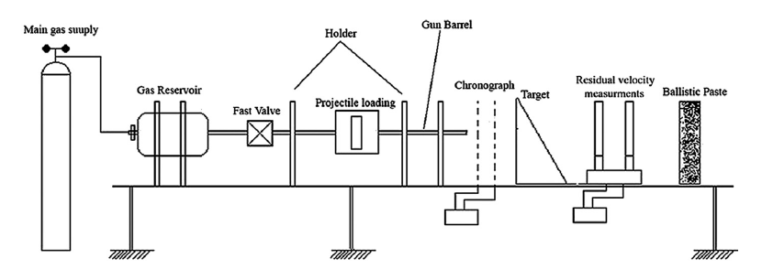

# 3. Mathematical Model and Assumptions

In order to simulate the experiment in ANSYS, a few assumptions and simplifications need to be made.

The first thing to consider about is the boundary conditions. The tested plate was fixed on the four edges by a holder, which has a 160*160 mm hole in the center of it. It is simplified as a 160*160 mm plate with fixed boundary condition on the four edges of all three layers.

As the geometry and force in this case are all symmetric, this model could be further simplified as one quarter of it. While applying the symmetry scheme in this model, the two separation plane are the x-z plane and y-z plane. There should have no displacement normal to the symmetry plane and no rotation parallel to plane too. The boundary conditions are shown in the following figure and table.

The projectile is allocated with an initial condition of velocity, which is set according to the experiment inlet velocity. The projectile is also symmetrised, so the boundary conditions on the symmetry plane are applied to it too.

*Table 1: Boundary Condition and Force*

|  |  |
| --- | --- |
| **Label** | **Boundary Condition** |
| A | Fixed support |
| B | Symmetry Region |
| C | Symmetry Region |

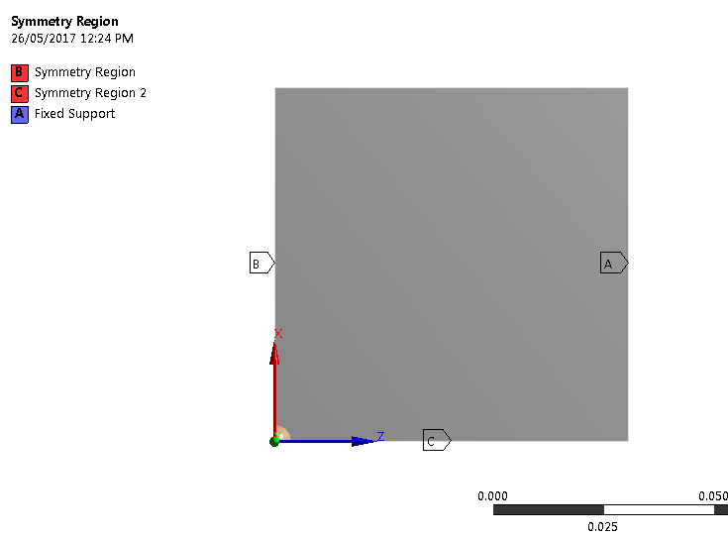

*Figure 1: Simplified Geometry and Boundary Conditions*

# 4. Mesh and Refinement

## 4.1 Mesh Method

When we are trying to set the meshes of the geometry, there are a lot of options need to be chosen: structured or unstructured, quadrilaterals or triangles. Meshing method could have great influence on the accuracy of our results, so they need to be carefully decided.

In this project, structured mesh is chosen, as structured meshing method normally has better accuracy and takes less computational resource. When taking transient analyses and applying explicit dynamic module, the solving time could be very long due to its complexity. So computational resource saving is a critical consideration here.

The projectile ball is hard to set as structured mesh. It is not our main investigate target and its mesh would has little influence on the result, so it is set with a coarse unstructured mesh.

In order to get a better mesh and develop more accurate result, smaller size mesh elements are allocated around the impact area. A mesh refinement procedure is carried out in the following part.

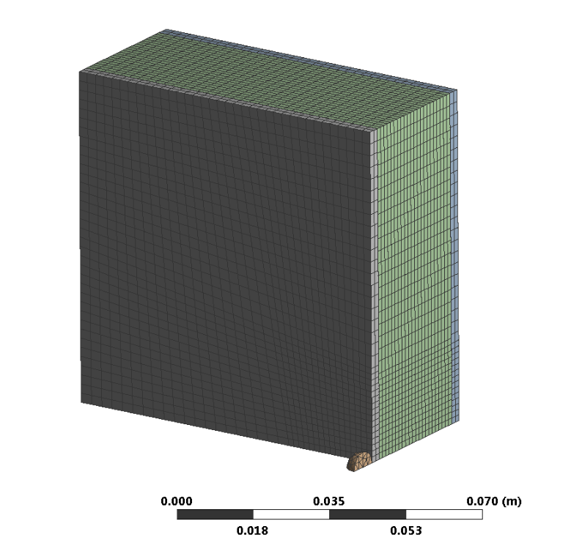

*Figure 2: Unstructured Mesh and Structured Mesh*

## 4.2 Mesh Refinement

The purpose of the experiment simulation is to develop a reliable model. The residual velocity is set to be the validation data. In consider of this, the residual velocity of the projectile is used here as the mesh refinement indicator.

When the initial inlet velocity is set to a certain value, 400 m/s here, it is clear that as the mesh element number increases, the residual velocity converged to a certain value. More element takes more calculation time, especially in the transient analyses case. A compromise needs to be made between accuracy and time consuming.

The 30,000 element model is chosen in this project, as it relatively accurate and took a reasonable time (about 20 minutes) to solve the results.

*Figure 3: Mesh Convergence*

# 5. Results

Figure 4 shows the stress distribution after the impact of 360 m/s velocity. This figure is at the end time of 0.5 mms. As is shown in the figure, the projectile almost went through this composite board, but still remains in the back board. Looking into figure 6, it could be found that the velocity of the projectile dropped from the 360 m/s to 5 m/s. This means that 360 m/s could be taken as the ballistic limit.

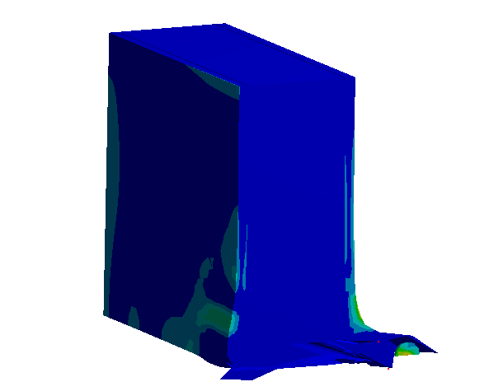

*Figure 4: Stress distribution*

The impact velocity was changed from 80 m/s to 600 m/s to find out its corresponding residual velocity. The results are shown in figure 6. It could be confirmed again that the ballistic limit is around 360 m/s. If the projectile has lower initial velocity than this, it could not go through this composite board and will stuck in the material. The purpose of this project is to design a light enough composite material board which has a higher ballistic limit to withstand the debris shock during storms.

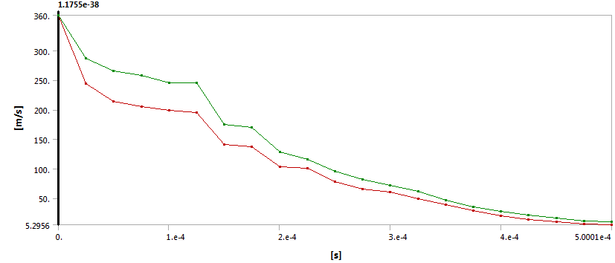

*Figure 5: Velocity of the Projectile through Time*

# 6. Validation

The validation process is to make sure that our simulation could represent reality. The most direct method is to compare our simulation result with the experiment data. This comparison is illustrated in figure 6.

As could be seen, the simulation results fit quite well to the experiment data, especially in higher velocity margin. There is still some difference in the ballistic limit area. The simulation limit is about 360m/s as discussed in former part, while the experiment ballistic limit is about 320 m/s. The difference is about 12%. So we may need to take a safety factor larger than 1.2 to avoid this difference effect.

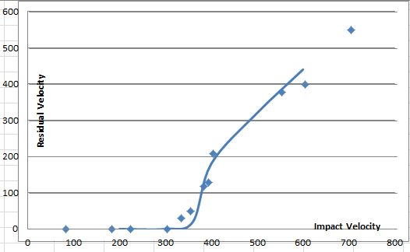

*Figure 6: Simulation Results Compare to Experiment Data*

# 7. Window protection board design

The whole process in the former part of this report is trying to build a reliable composite material model. Then the window protection board could be designed rely on this model.

The design process is similar to the former part. Firstly, a board model needs to be built according to the geometry of a window. Then make appropriate boundary conditions and initial conditions. Thirdly, it’s the meshing process and at last, solution and result discussion. This process is run multi times with different core thickness, until the best value is found.

## 7.1 Model of Window Protection Board

A model of window protection composite material board is developed in this section. The dimension of this board is 2000*1000 mm2, and the thickness is set to be the same initially as the former model, which are two 3 mm face-sheets and a 30 mm core.

According to the Design guidelines for Queensland public cyclone shelters [5], in Queensland’s tropical cyclone region, the 1 in 10,000 years’ probability based criterion, V10,00 is 306 km/hr, which equals to 85 m/s. This design guideline also set two debris loads criteria for public cyclone shelters:

1. Five spherical steel balls of 2 grams mass (8 mm diameter) impacting at 0.4 * V10,00 (34 m/s) for horizontal trajectories and 0.3 * V10,00 (25.5 m/s)for vertical trajectories;
2. A 100 mm * 50 mm piece of timber of 4 kg impacting end-on at 0.4 * V10,00 for horizontal trajectories and 0.1* V10,00 (8.5 m/s)for vertical trajectories.

The first criterion is taken in this project. Five steel balls of 2 grams mass are simplified as one ball of 10 grams (20 mm diameter). Take five projectile into one should be more dangerous for the protection board, so this simplification is considered to be safe.

The boundary conditions are the same as the former model: fixed support on the four edges. This model is also symmetrised along the two center plane. So symmetry boundary conditions also need to be applied. The geometry and boundary conditions of this model is shown in figure 7 bellow.

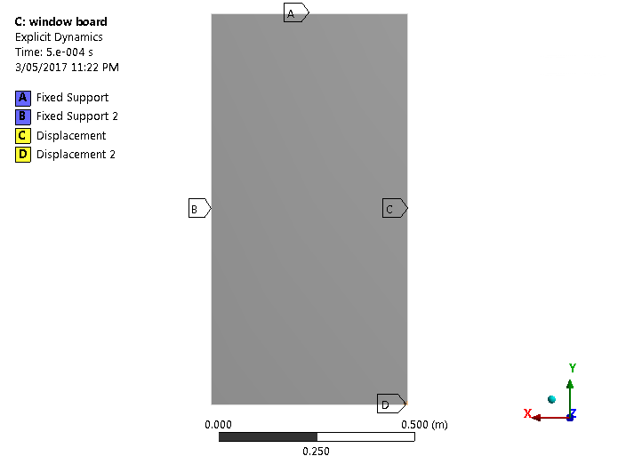

*Figure 7: Geometry and Boundary Conditions of The Protection Board Model*

## 7.2 Mesh and refinement

The meshing method is similar to the former model. Structured mesh is utilized to save computational resource and time consumption. The mesh of the projectile is set to be coarse. A spherical body size is allocated near the impact region to refine this area. One edge size is set on the two face-sheets thickness direction to make sure there are more than 4 layers on each sheet. The meshing result is shown below in figure 8.

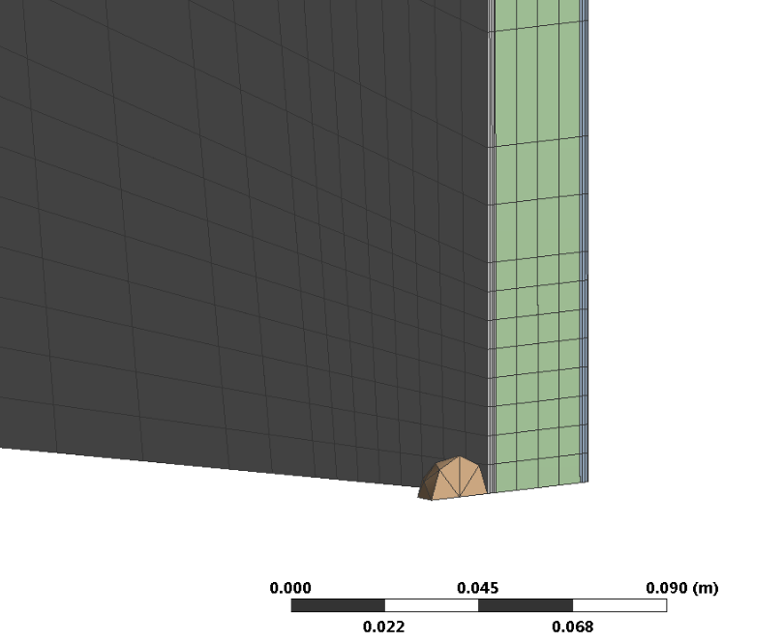

*Figure 8: Mesh of The Protection Board Model*

The residual velocity is also set as the mesh refinement indicator. A certain impact velocity is given, as the number of mesh element increase, the residual velocity converge at a certain value. The convergence process is show in figure 9.

*Figure 9: Mesh Convergence*

## 7.3 Results and Discussion

In this section, the minimum core thickness is calculated through another several times of simulation. This process started from the original core thickness of 30 mm and then decrease in each time. Until the projectile of 34 m/s could shoot through the board. This procedure is shown in the following figure. After we found the limit thickness, a safety factor of 1.2 is multiplied as discussed in the former part.

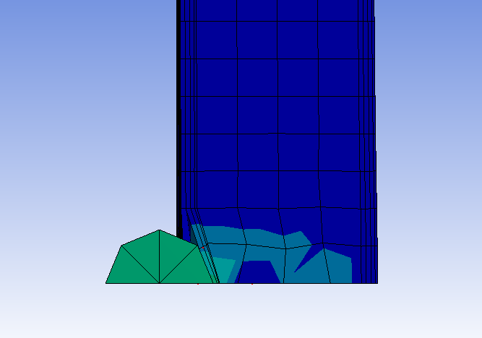

*Figure 10: Deformation for the Initial Model*

As is shown in figure 10, the projectile could not shoot through the initial model. So the thickness of the core material was decreased. The residual velocity is still taken as indicator, the plot is shown below in figure 11.

Seen from figure 11, the critical core thickness is around 10 mm. Multiply it with the safety factor of 1.2, gives the final core thickness of our design is 12 mm.

*Figure 11: Core Thickness Design*

# 8. Conclusion

The composite material window protection board is designed out now, it has two layers of 3 mm face-sheets, and one layer of 12 mm PVC foam core. This board is available to provide protection in cyclones according to the definition of Design guidelines for Queensland public cyclone shelters [5]

This board model is reliable as it was validated through comparison with experiment data. Although there is no data to validate our final model. This model could be modified in dimensions to design other kind of window protector.

Due to a factor of time, only core thickness variation is simulated in this project. The face-sheet thickness and other materials should also be checked to finish this design work.

# Reference

[1] Shirley K. Gastillo, Brenda L. Buitrago, Behavior of sandwich structures and spaced plates subjected to high-velocity impacts.2011

[2] Ivanez Santiuste, E. Barbero, Numerical modelling of foam-cored sandwich plates under high-velocity impact, 2011

[3] Rasoul Nasirzadeh, Study of foam density variations in composite sandwich panels under high velocity impact loading, 2014

[4] Md. Ansari, Behaviour of GFRP composite plate under ballistic impact: experimental and FE analyses, 2016

[5] Mulins consulting Pty Ltd, Design guidelines for Queensland public cyclone shelters, 2006

[6] Ulrich Frye, Simulated wind driven debris impact testing of crimsafe debris screen, 2010

[7] Standards Australia, Standards New Zealand, AS 1170.2:2011 Structural design actions Part 2: Wind actions, 2011